12U ENCLOSURE 19"CABINET 600X1000 FLOOR STANDING SERVER RACK CABINET 12U
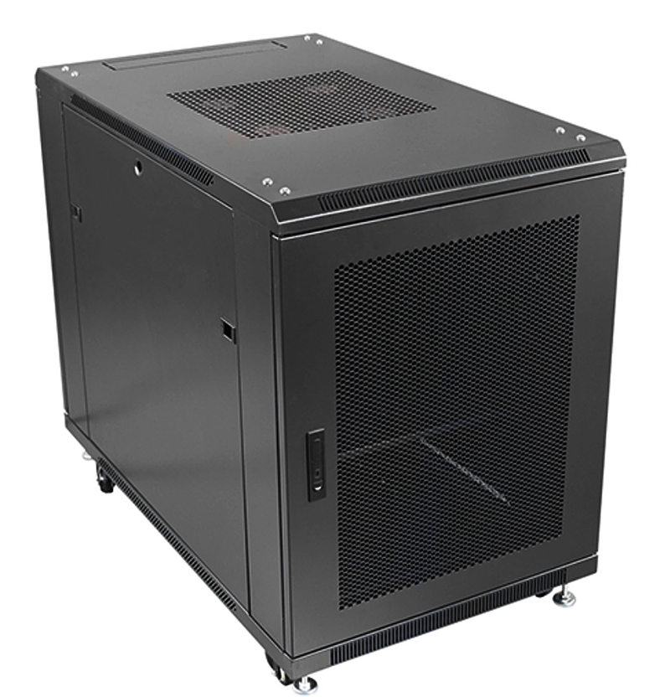

DESCRIPTION
The CAB-FE-12U-6100NA is a small enclosure/Server Rack Cabinet 12U, built for the housing of standard size 19” inch devices, the enclosure is 600mm width and 1000mm deep compatible to house regular Servers, SAN, UPS and other networking devices.
The cabinet is designed to fit in smaller places than the regular server enclosures, able to store under a desk or staircase. Designed through air ventilation, built in accordance to industrial standards , more fans or temperature modules can be added.
The CAB-FE-12U-6100NA is a compact server enclosures which can fit under a desk or in a corner, while still having all the features needed to store a high end server with accessories needed which would be expected by IT integrators. The Server Rack Cabinet 12U includes through air ventilation which can be expanded according to requirements, 19-inch wide profiles together with front and rear adjustable profiles, thick gauges to carry the extra weight of a fully populated server, UPS or other electronic networking device.
Complementing the design is the industry standard, 1000mm depth to
facilitate almost all servers with the extra benefit of increased airflow. This has been
further enhanced with the integral front meshed door to allow ambient air to
circulate correctly and thus reduce server downtime. As with LMS Data enclosures, a
fitted roof fan-tray provides effective removal of warm air from the enclosure
and thus the LMS Data compact server enclosures are your ideal choice for mission
critical applications - big or small.

SPECIFICATIONS
12U high 600W 1000D
ETSI 19” front/rear profiles, adjustable
Lockable mesh front door, reversible if required
Removable side panels, rear lockable door
Ideal for Dell(tm), IBM(tm), Fujitsu(tm) servers
Supplied with Castors and Jacking Feet
UK Assembled and quality assured

TECHNICAL INFO

SKU/MPN: CAB-FE-12U-6100NA
EAN: 8400800031143
Dimensions: 600 (width) x1000 (depth) x720mm (height)

FILES
Datasheet - CAB-FE-12U-6100NA

